TYRE

Brand Name: DISTANCE,  DELUN, GOODTYRE, GOLDTYRE, YINBAO

Type: 215/75R17.5,235/75R17.5

Certification: ISO9001, ISO10012, CCC, DOT, ECE, INMETRO, SNI, GCC, BIS, SASO, SONCAP, NOM,ETC

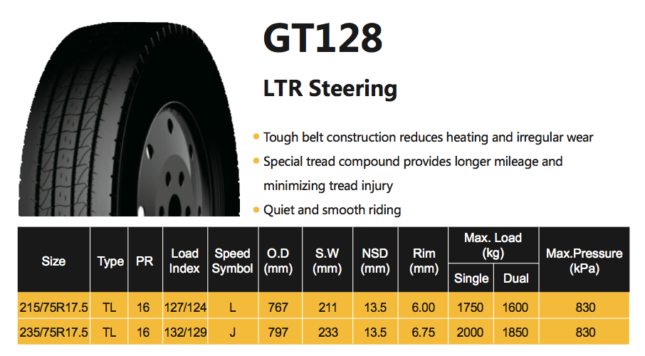

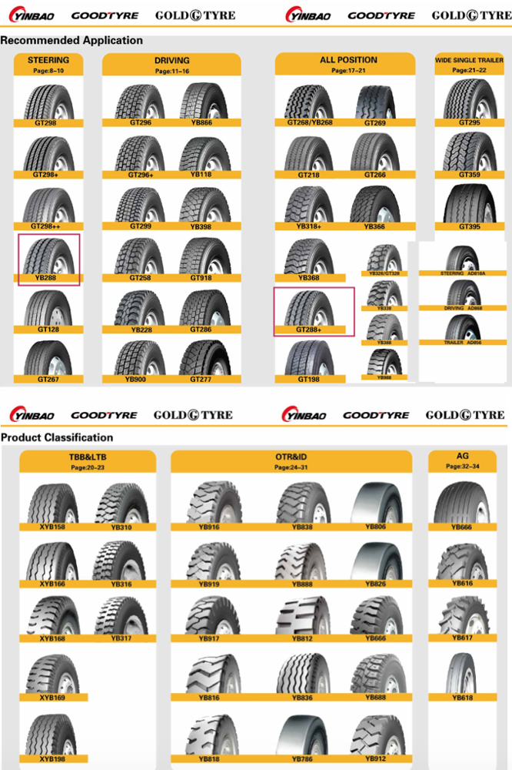

Price:

**US $50-80** / Piece | 130 Piece/Pieces (Min. Order)

Supply Ability:

400000 Piece/Pieces per Year

Port:

NanJing

**Quick Details**

Place of Origin:

Anhui, China (Mainland)

Brand Name:

Distance

Model Number:

215/75R17.5,235/75R17.5

Tire Design:

Radial

Type:

Tubeless

Diameter:

16-20inch

Width:

205-225mm

Car Make:

TBR

Advantage:

Tire factory with more than 20 years technology

Warranty:

Warranty Policy

Pattern:

Steering

Technology:

Japan Technology

PR:

16

Rim:

6.00/6.75

Speed Symbol:

L/J

Equipment:

Germany,Italy,Chinese

Keywords:

Chinese Tire,Radial,TBR,215/75R17.5,235/75R17.5

Certificate:

DOT,GCC,ECE,SASO,SNI,BIS...

**Packaging & Delivery**

Packaging Details

1. Standard Packing, Wrapped in Plastic Paper;   
2. Nude Package   
3. As Customer's Request

Delivery Time

Within 25 days

**Company Information**

 DELUN TIRE Co.,LTD as one of the branch factories of SHANDONG YINBAO TYRE GROUP is opened up with the most modern and experienced tire technology and production equipments.The products cover full range of TBR with the brand of "DISTANCE" and "DELUN".The YINBAO GROUP invested advanced tire manufacturing and inspection equipments from Germany and Italy. Currently, we produces over 200 sizes on TBR,OTR,LTR,TBB,LTB,AGR and INS tires.  
"Continuously Creating Great Service Value" in the business, takes orders of "Quality First,Consumers First" has been ranked top class among well-known tire manufacturers. Our products are already passed on many international certificates,ISO9001,USA DOT,ECE,INMETRO,SNI,GCC,ISO10012 etc.  
We will keep group's philosophy "To Satisfy the Customers" and will keep continuous efforts on developing and supplying high quality products to our customers all over the world.

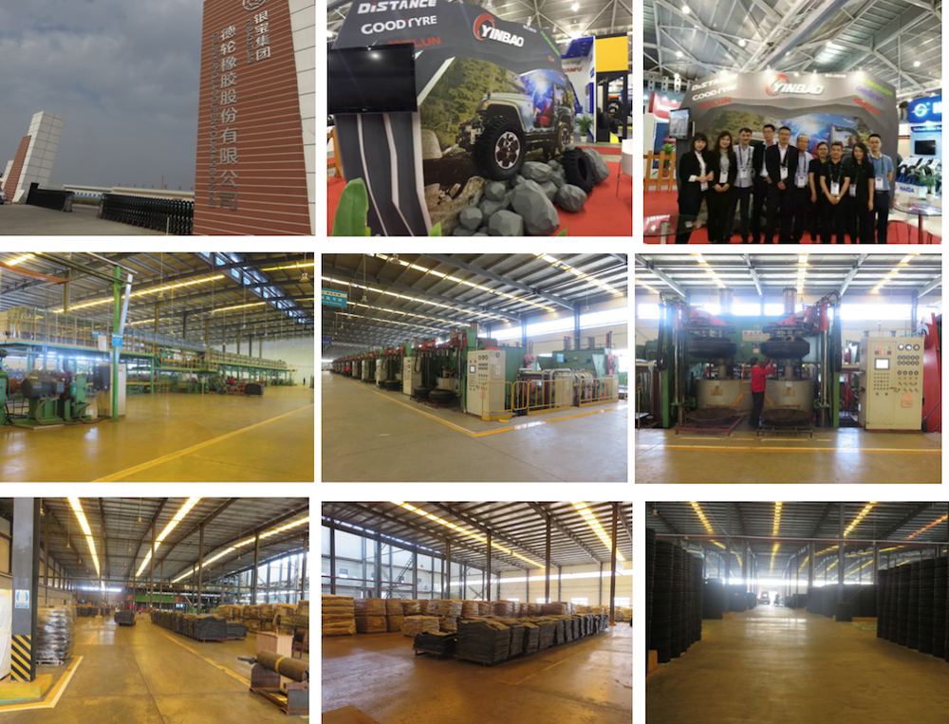

Diesel engine assy L340-33 for auto

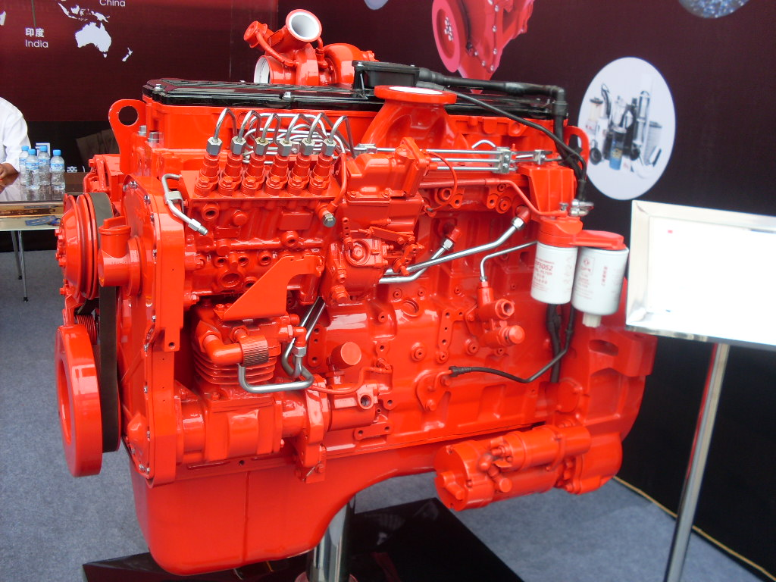

FOB **Reference** Price:

**US $8,000-10,000** / Set | 1 Set/Sets (Min. Order)

Supply Ability:

5000 Set/Sets per Month OEM order accepted

Port:

Shanghai or Shenzhen

Seller Support:

[Trade Assurance– To protect your orders from payment to delivery](https://tradeassurance.alibaba.com/?tracelog=from_detail_learnmore)

Payment: L/C, T/T, Western Union,Paypal

**Quick Details**

Type:

Diesel Engine

No. of Cylinders:

4 Cylinder

Power:

Standard

Displacement:

8.9L

Torque:

280/2000 Nm (kg-m)/rpm

Place of Origin:

Hubei, China (Mainland)

Brand Name:

OEM

Model Number:

engine assy

Warranty:

1 Years

Application:

Truck

Key Word:

diesel engine assy

Name:

Diesel Engine

Material:

Steel

Engine Model:

6BT/4BT/6CT/6L/ISLE/6ISDE/ISBE/QSB/QSC

Car make:

Fit

Packing:

WOODEN CASE

Model:

auto diesel engine assy

**Packaging & Delivery**

Packaging Details

Original packing or wooden packing

Delivery Time

within 15 days

**cummins L340-33 diesel engine assy for Dongfeng trucks**

|  |  |
| --- | --- |
| L340-33 diesel engine assy for Dongfeng trucks | |
| Applied excavator : L340 | Engine model:  L340-33 |
| Condition: New | Brand:OEM |
| Place of origin : CHINA | Payment term :T/T ,  Western Union , L/C |
| Manufacturer : HUBEI | Packing : As request or standard packing |
| Delivery time : Based on order | Means of transport :By sea/air, DHL |



**Product Description**

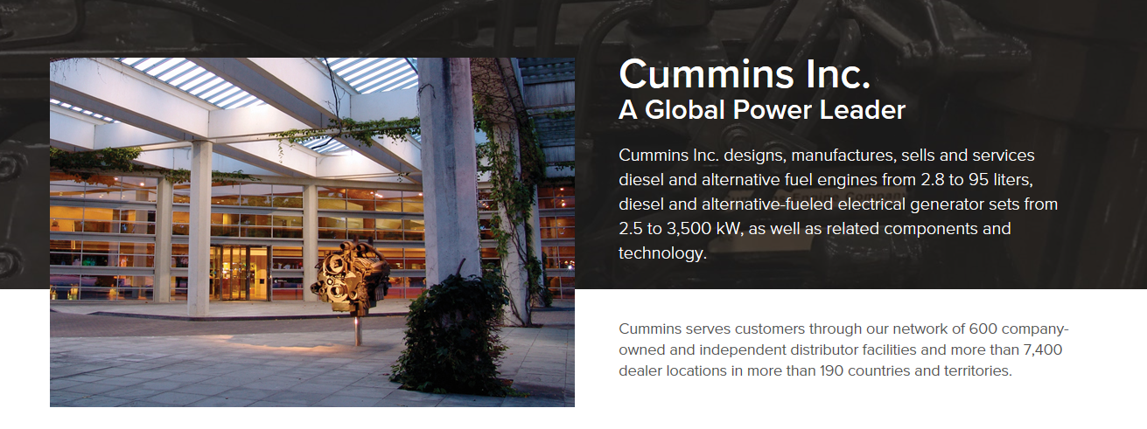

**Packaging & Shipping**

 Packaging:  standard pacage or as customer request.

 Dlivery time: About 10-30 days after received the payment.

**Our Services**

Pre-sale guide

   if you're not sure what kind of accessories you need, just send us some relevant information, like your car's picture or the part number, we have very experienced engineers will find it for you. and can support the technical guidance.

After-sale service

a we have our own spare parts warehouse.

b  Supply original parts with wholesale price.

c Send the spare parts at the shortest time.

A loving team, delicated service.

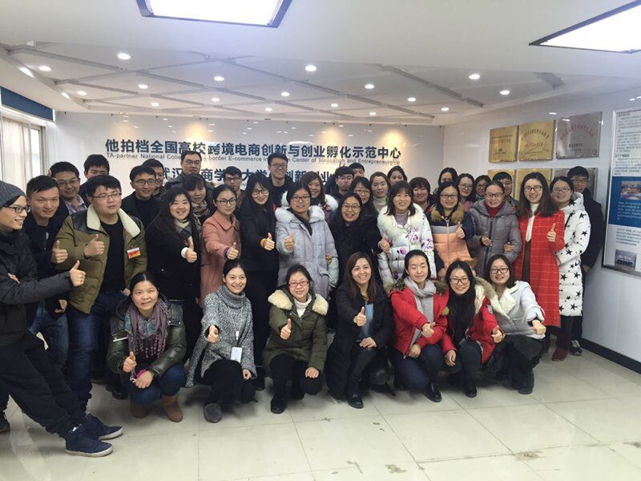

**Company Information**

Located in Shiyan city, Hubei Province, Renman Auto Parts is an authorized Cummins® Dealer that specializes in serving the needs of Cummins spare parts such as A2300, ISF2.8/3.8, 4BT3.9, 6BT5.9, 6CT8.3, 6L8.9, QSB6.7, ISBe, ISDe, ISLe, ISM, QSC, QSL,QSX,ISX,X15,QSM, M11, L10, N14, NT855, KTA19/38/50.

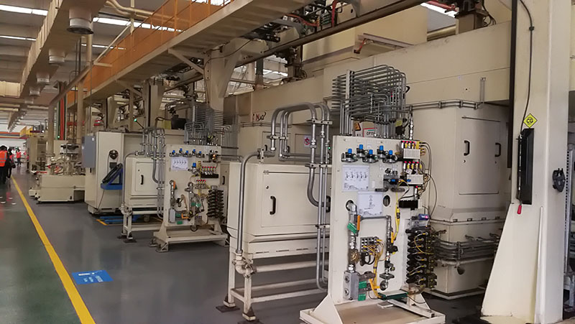

**What service you can supply for buyer?**

a    Competitive Price----we have our own factories, from raw material procurement to production and processing package delivery, every link is controllable. Therefore, the quality is guaranteed, and our price is the best.

b    Quick Response------Our team is consisted of a group of diligent and enterprising people, working 24/7 to respond client inquiries all the time. Most problem can be solved within 12 hours.

c    Fast Delivery-------Normally it will take more than 15 days for other manufactures to prepare the goods. While we have a variety of resources, locally in the Motor City of China----Shiyan. We can find any regular parts for you.

**Which payment terms can we accept?**

a    On T/T term, 30% down payment is required in advance, and 70% balance shall be paid before the shipment.

b    On L/C term, a 100% irrevocable L/C without “ soft clauses ”can be accepted. Please seek the advice from the individual sales manager whom you work with.

**How  long will our price be valid?**

    We are a tender and friendly supplier, never greedy on windfall profit. Basically, our price remains stable through the year, We only adjust our price based on two situations:

a   The rate of USD: RMB w=varies significantly according to the international currency exchange rates.

b   Because of the increasing labor cost and raw material cost. All the special situation, we will explain in advance.

If still have any question, please feel free to contact our staff.  :)

# car racing seat

# 

**Price**

**US $30-55** / Piece | 5 Piece/Pieces (Min. Order)

Supply Ability:

500 Piece/Pieces per Day

Port:

shanghai or ningbo port

Seller Support:

[Trade Assurance– To protect your orders from payment to delivery](https://tradeassurance.alibaba.com/?tracelog=from_detail_learnmore)

Payment: L/C, T/T, Western Union, paypal.

Shipping:

Less than Container Load (LCL) Service to USGet shipping quote

**Quick Details**

Type:

Sport Seat

Material:

PVC

Size:

500mm*540mm*930mm

Place of Origin:

Jiangsu, China (Mainland)

Brand Name:

XJM

Model Number:

XJM-1006

recliner:

optional

slides:

optional

color:

optional

out material:

optional

**Packaging & Delivery**

Packaging Details

carton packing,2pcs/ctn

Delivery Time

10-22 days

**Product Description**

**12 colors can be choosed**

**Packaging & Shipping**

* **We pack by carton, if delivery by LCL, we suggest our customers pack by pallet. And the customers should pay for the pallet.**
* **Normally, one pallet can load 12-24cartons.**

**Our Services**

**We can take photos for your supervise at any time;**

* **We are more continuous innovation, research and positivespirit, to accept yourfeedback, tailor-made foryou to produce personalized to meet your seats.**

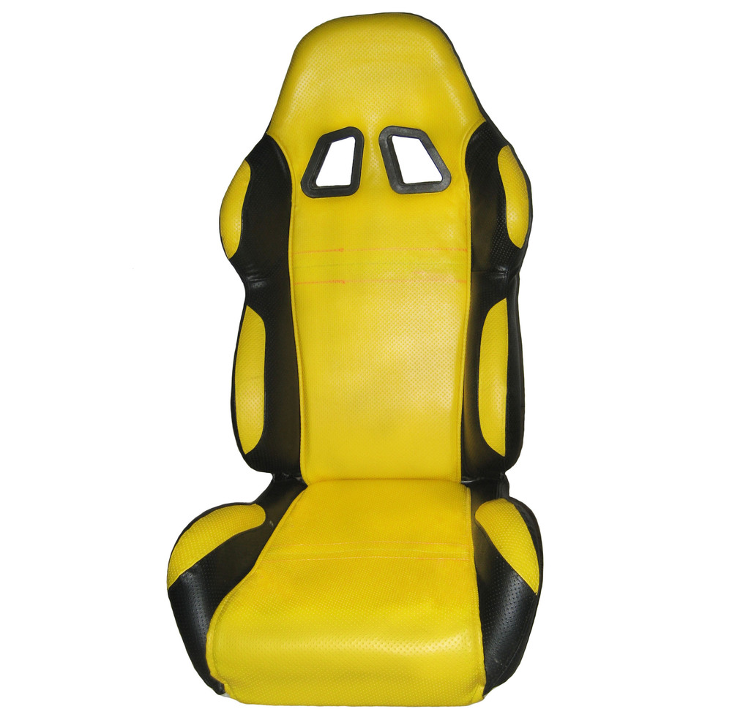

**Company Information**

**Danyang jiamei co., LTD. Is the production of engineering machinery seat, farm machinery class seats, car seats, karting seats and other professional manufacturers, annual output can reach more than 120000 sets. Agricultural harvest machinery industry in 2012 the seat to achieve the market share of 20%; Our factory technical force is abundant, the independent development ability is stronger, detection means complete, has a modern steel structure factory building, large forming machine, large shears, bending machine, automatic painting line, foaming line and other advanced equipment, the seat assembly adopts the flow process. In 2006 through the ISO9001 international quality system certification, in 2009 through the CQC quality certification (3 c) products, our factory has a complete quality management system operation.**

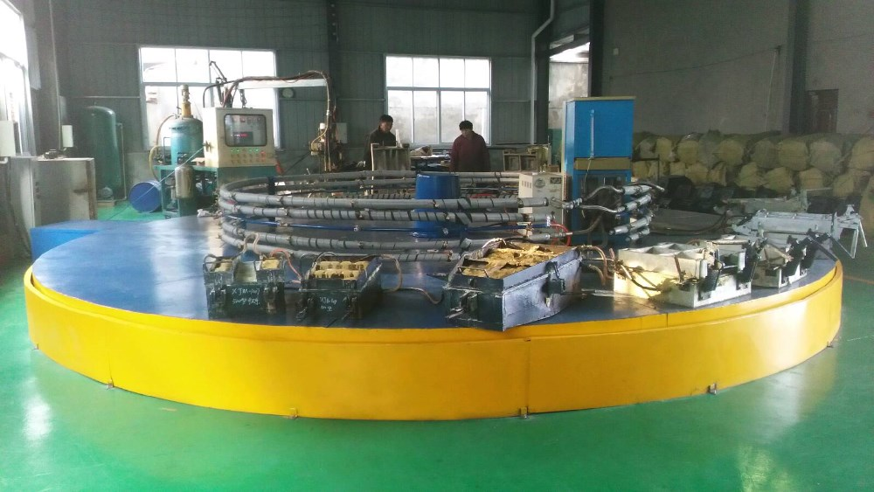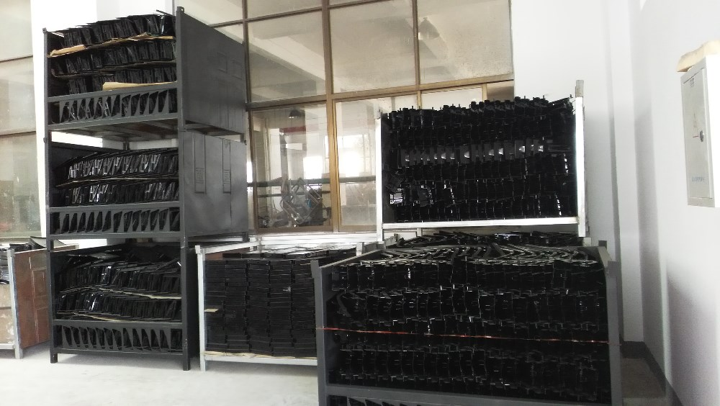

**Sample Policy**

we do not supply free sample. If you need sample, you should pay for the sample cost and express fee.

For the sample charge, we will refund to you in future order.

**Attention**

we pack by carton, if delivery by LCL, we suggest our customers pack by pallet. And the customers should pay for the pallet.

Normally, one pallet can load 12-24cartons.

# Casting Steering Wheel

# https://is.alicdn.com/img/pb/334/055/559/559055334_708.jpg

Price

**US $0.1-100** / Piece | 1000 Piece/Pieces (Min. Order)

Supply Ability:

360 Ton/Tons per Month

Port:

qingdao

Seller Support:

[Trade Assurance– To protect your orders from payment to delivery](https://tradeassurance.alibaba.com/?tracelog=from_detail_learnmore)

Payment: L/C, T/T, Western Union, Paypal

Shipping:

Less than Container Load (LCL) Service to USGet shipping quote

**Product Details**

Type:

Steering Gear

Size:

OEM

Place of Origin:

Shandong, China (Mainland)

Brand Name:

TLL

Model Number:

Casting

casting wheel:

steering wheel

process:

Casting

adhibition:

auto parts,boat

**Packaging & Delivery**

Packaging Details

As per your demand.

Delivery Time

within 30days..

Description:**Casting Steering Wheel**

Basic information as follows:

1.       Silicasol process precision casting and soluble glass precision casting

2.       Material: stainless steel casting, carbon steel casting, alloy steel casting

3.       Certificate: DIN, AISI, ASTM, BS, JIS, ect.

4.       Heat Treatment, polishing, plating, machining, ect.

5.       Application: Industrial parts, Machinery parts, hardware, construction parts, valve/valve parts.

If you are interested in my offers, please send me your detailled information such as your drawing and detailed specifications, chemical composition, etc, hope we could have a very nice start and build long-term relationship.

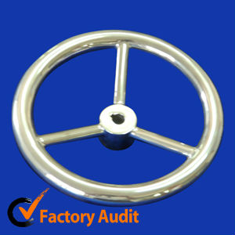

# Brand New India Yamaha Fazer 25 250cc Street Motorcycle

# https://sc01.alicdn.com/kf/UTB8K92Ki._4iuJk43Fqq6z.FpXaQ/230199056/UTB8K92Ki._4iuJk43Fqq6z.FpXaQ.jpg

Price:$1600-$2000

24 Unit/Units (Min. Order)

Supply Ability:

100 Unit/Units per Month

Payment: L/C, T/T, Western Union, Paypal

Shipping:

Less than Container Load (LCL) Service to USGet shipping quote

**Product Details**

Type:

250cc Motorcycle, 250cc Motorcycle

Fuel:

Gas / Diesel

Displacement:

250cc

Engine Type:

4-Stroke

Max. Speed:

> 80km/h

Certification:

Other

Condition:

New

Brand Name:

Yamaha

Place of Origin:

India

Model Number:

Fazer 250

Brake(F/R):

Disk/Disk

**Packaging & Delivery**

Packaging Details

Bare Packing : Wooden frame. 24 units / 20' container ; 48 units / 40' container

Delivery Time

Shipped in 21 days after payment

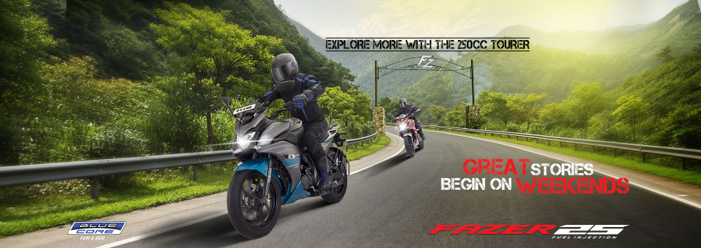

Specifications

|  |  |  |  |
| --- | --- | --- | --- |
| Model Name | Genuine Yamaha India Motorcycles Fazer 25 | **Country** | India |
| Length / Width / Height | 2015 x 770 x 1115mm | **Maximum Power** | 20.9PS / 8000rpm |
| Wheelbase | 1360mm | **Maximum Torque** | 20.0N.m / 6000rpm |
| Fuel Tank Capacity | 14L | **Displacement** | 249 cc |
| Weight | 154kg | **Fuel System** | FI |
| Engine Type | Air cooled, 4 stroke, SOHC,2 valve | **Brake ( Front/Rear )** | Disc/Disc |

Colors

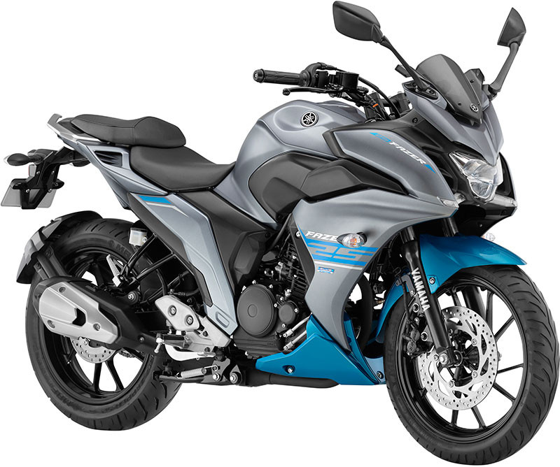

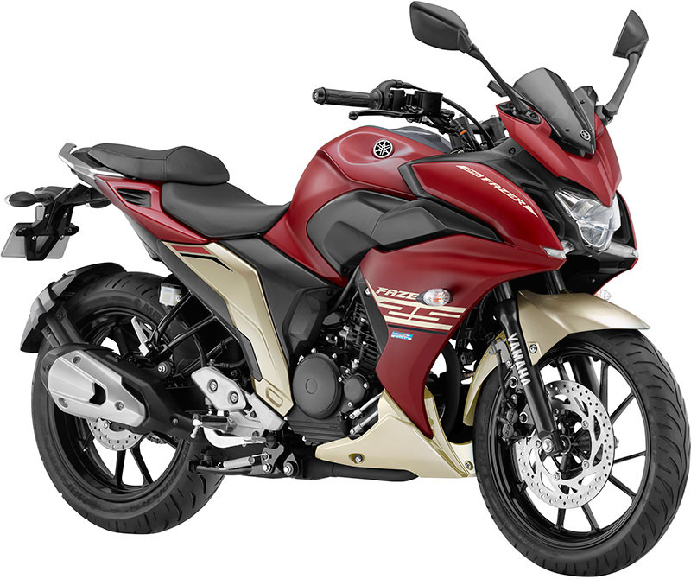

Packing & Loading

Bare Packing :  24 units / 20'  &  48 units / 40'

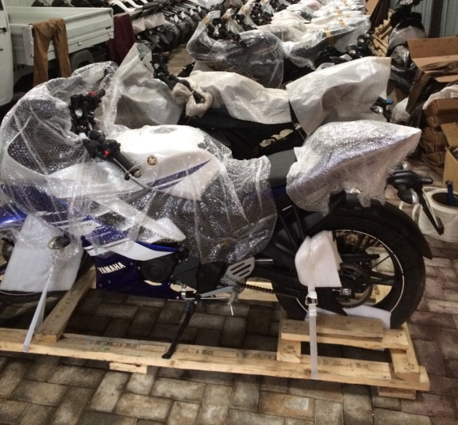

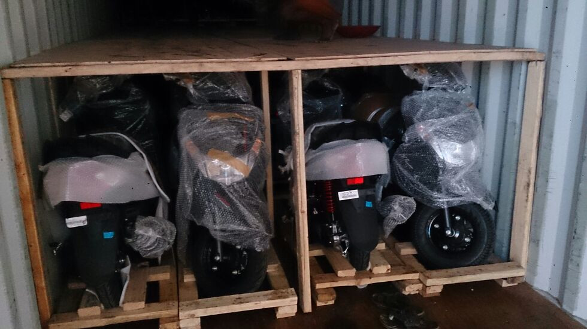

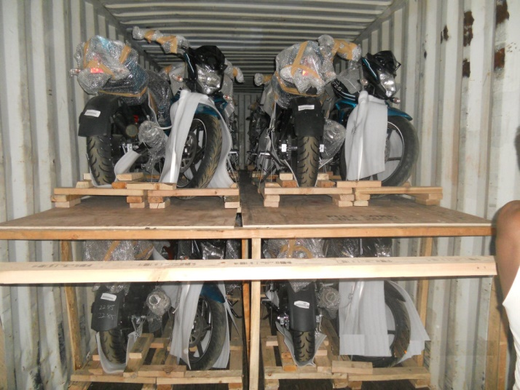

Related Products

[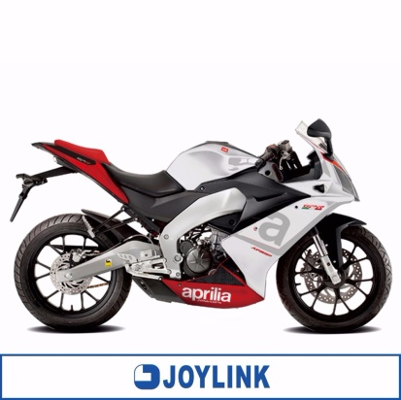](https://www.alibaba.com/product-detail/Genuine-China-Aprilia-Motorcycle-GPR-150_60610944227.html?spm=a2700.7724838.2017115.17.Zxe6X6)

[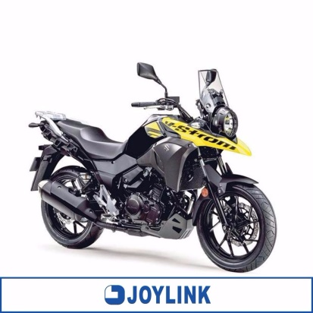](https://www.alibaba.com/product-detail/Genuine-China-Suzuki-Motorcycle-DL250-V_60611272407.html?spm=a2700.7724838.2017115.214.SO0X03)

[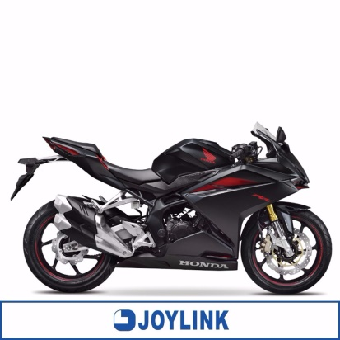](https://www.alibaba.com/product-detail/Hot-Indonesia-Honda-Motorcycle-CBR-250_60621455697.html?spm=a2700.7724838.2017115.1.jMqhCO)

Our Company

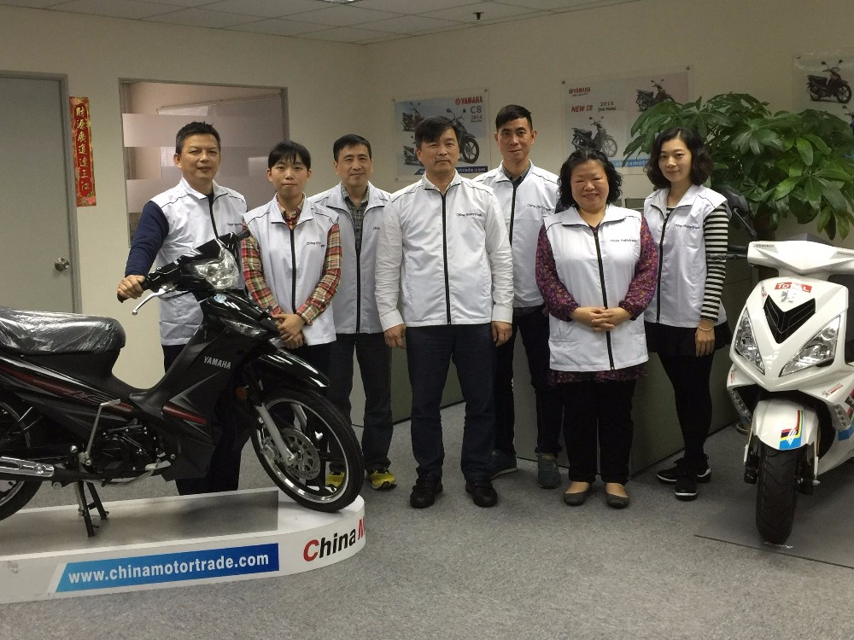

Having more than 10 years experience in the industry and with a stable and speedy supply network, we have been a leading exporter of world brand motorcycles to worldwide markets.   
Not only we supply a wide range of brands , but we also endeavor to maximize customer satisfaction and benefits , such on loading quantity, documentation and spare parts supply. 

For the past years, we have been active in Japan, Korea, Vietnam, Cambodia, UK, Cyprus and Africa countries.

For any enquiries, please feel free to contact us. Definitely we will always do our best to offer you the best solutions.

